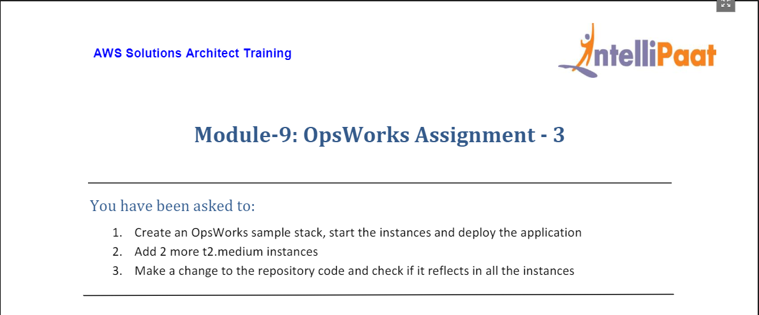

1. For this, we first need to create an IAM role that grants OpsWork administrator access to create and launch resources on our behalf.
2. We head to IAM and create role as shown below:

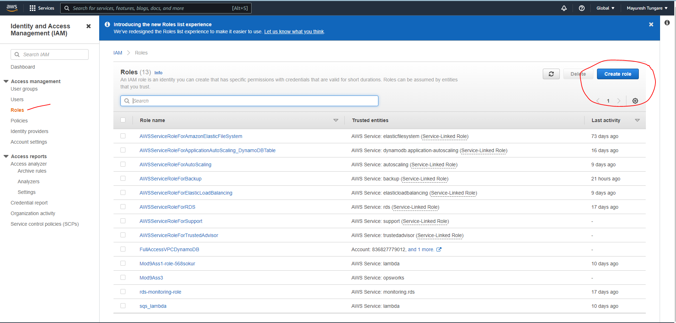

1. We select AWS Service and then OpsWorks as shown below:

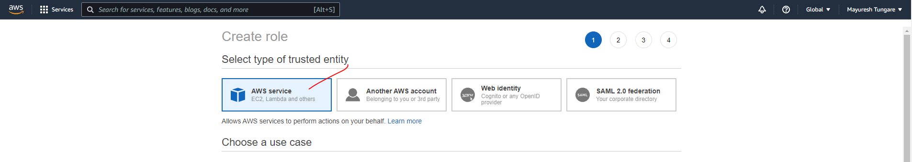

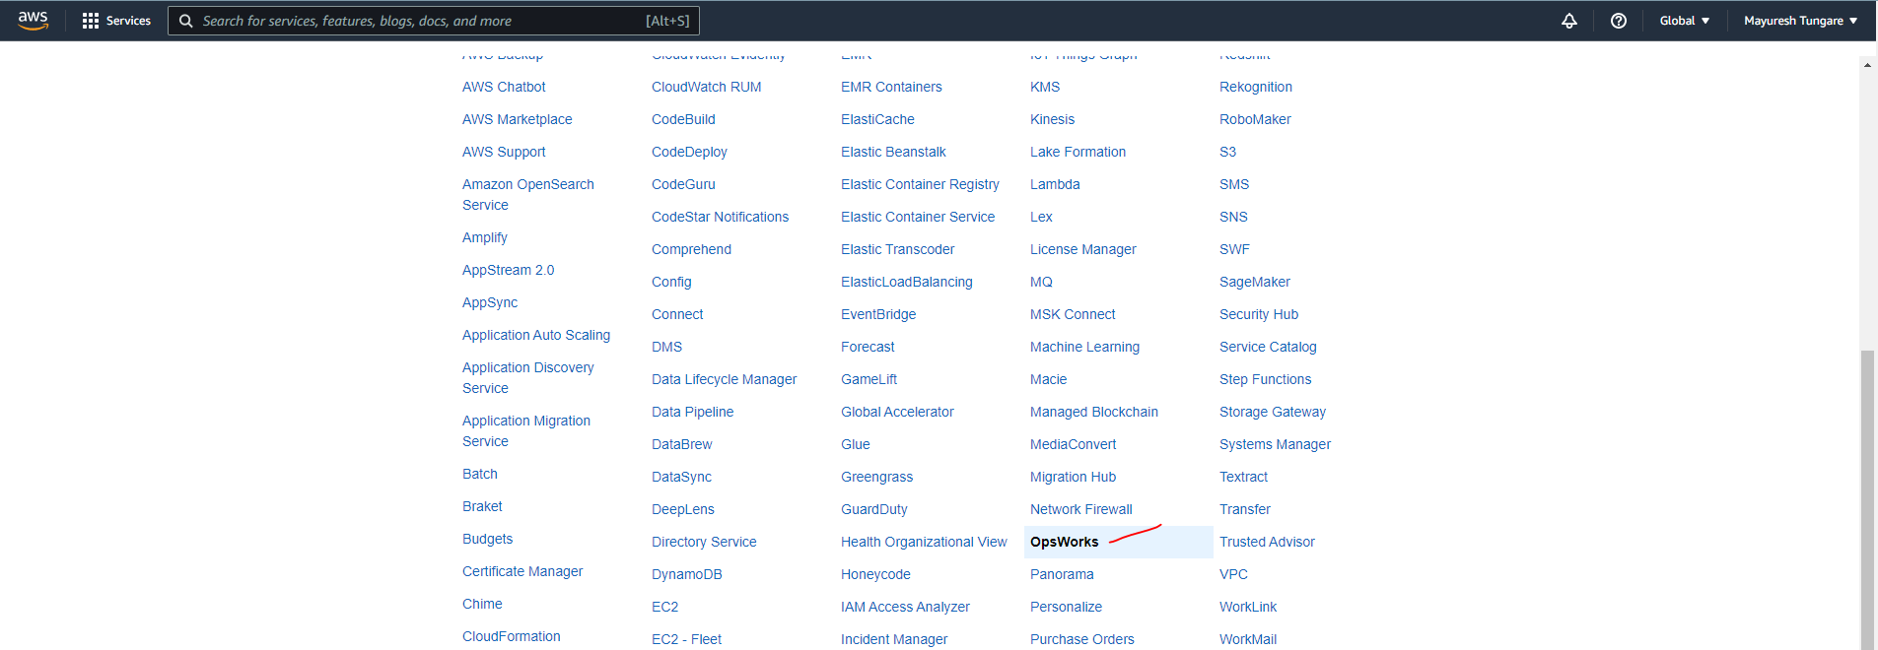

1. We then search for ‘Administrator Access’

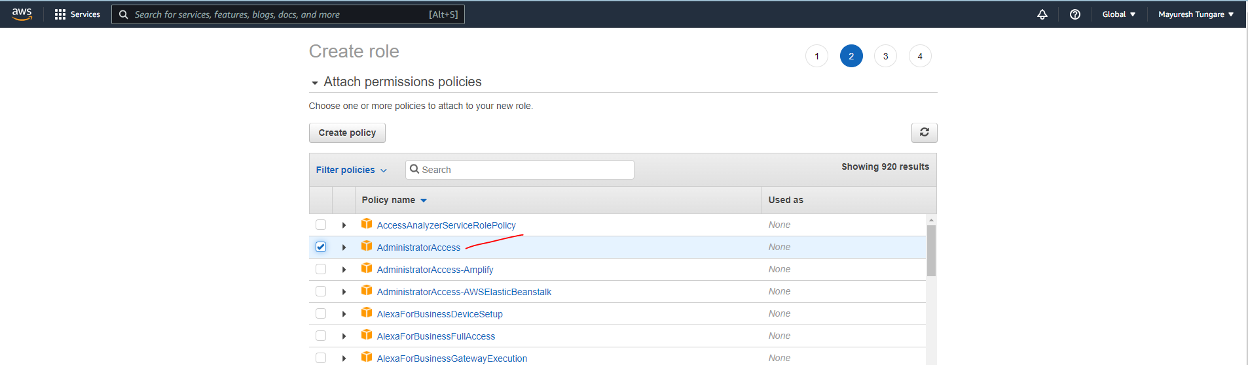

1. We then enter details as below and create role as shown below:

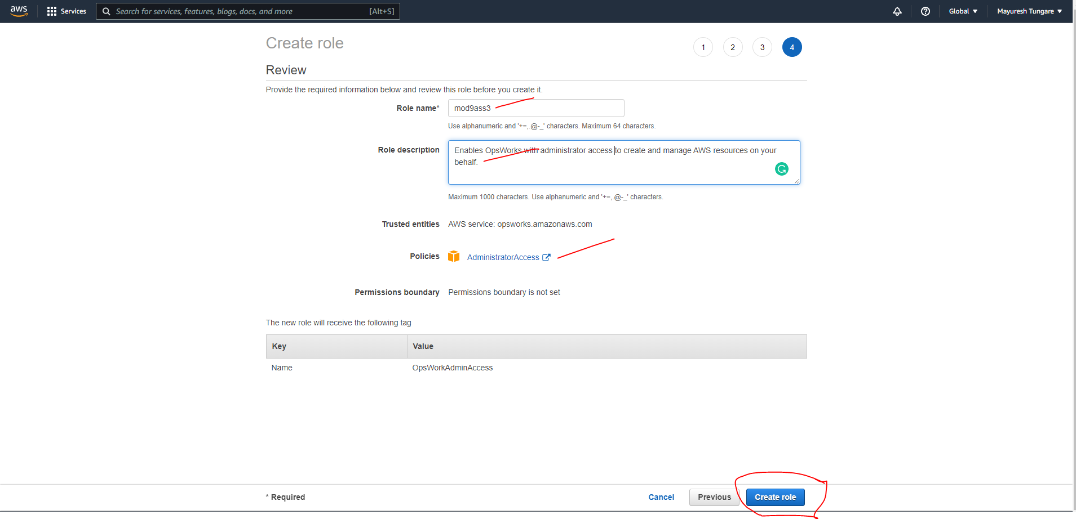

1. We now see that the role has been created:

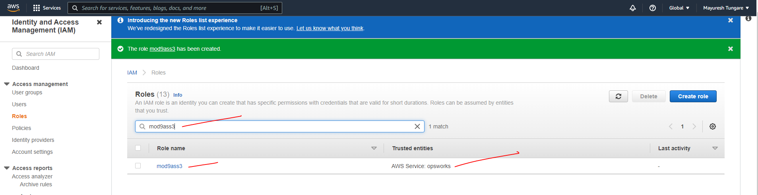

1. Next, we create an instance profile – this is a role that enables EC2 instances to access resources on our behalf.

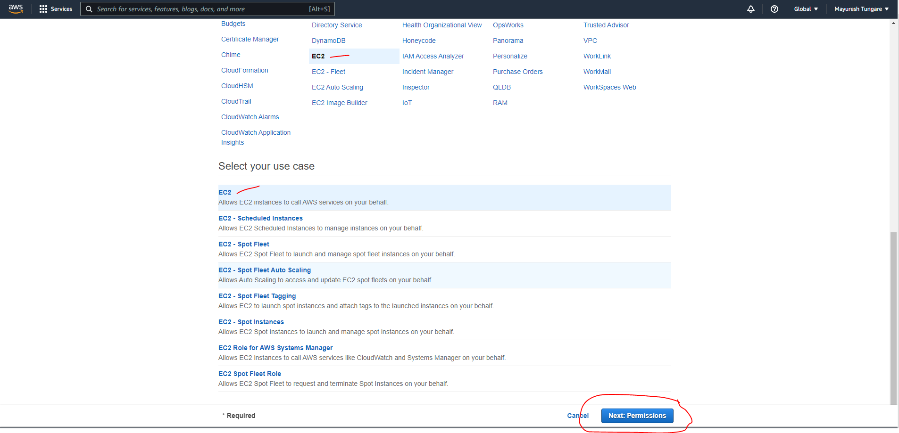

1. We enter details as shown below

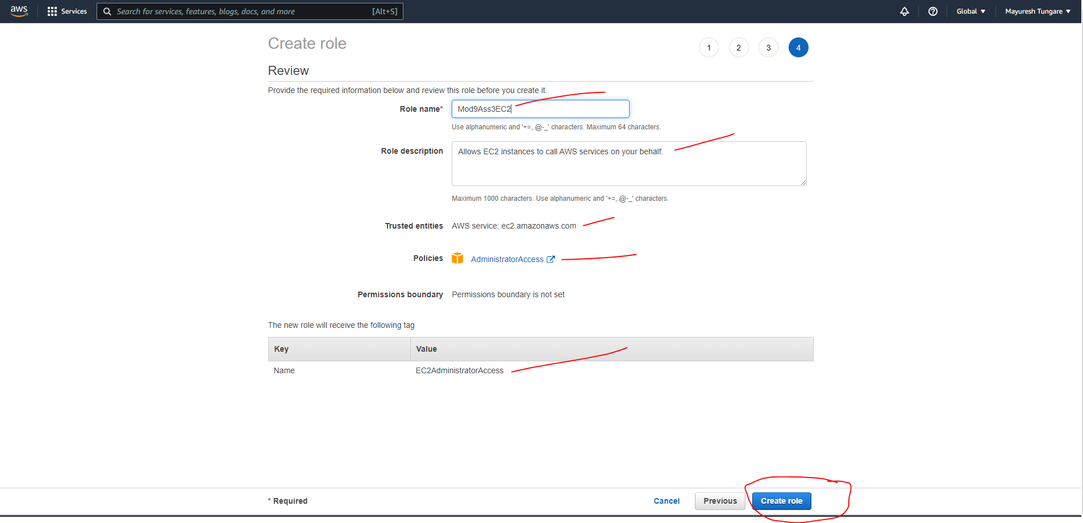

1. Next, we head to OpsWorks service from the AWS Management console.

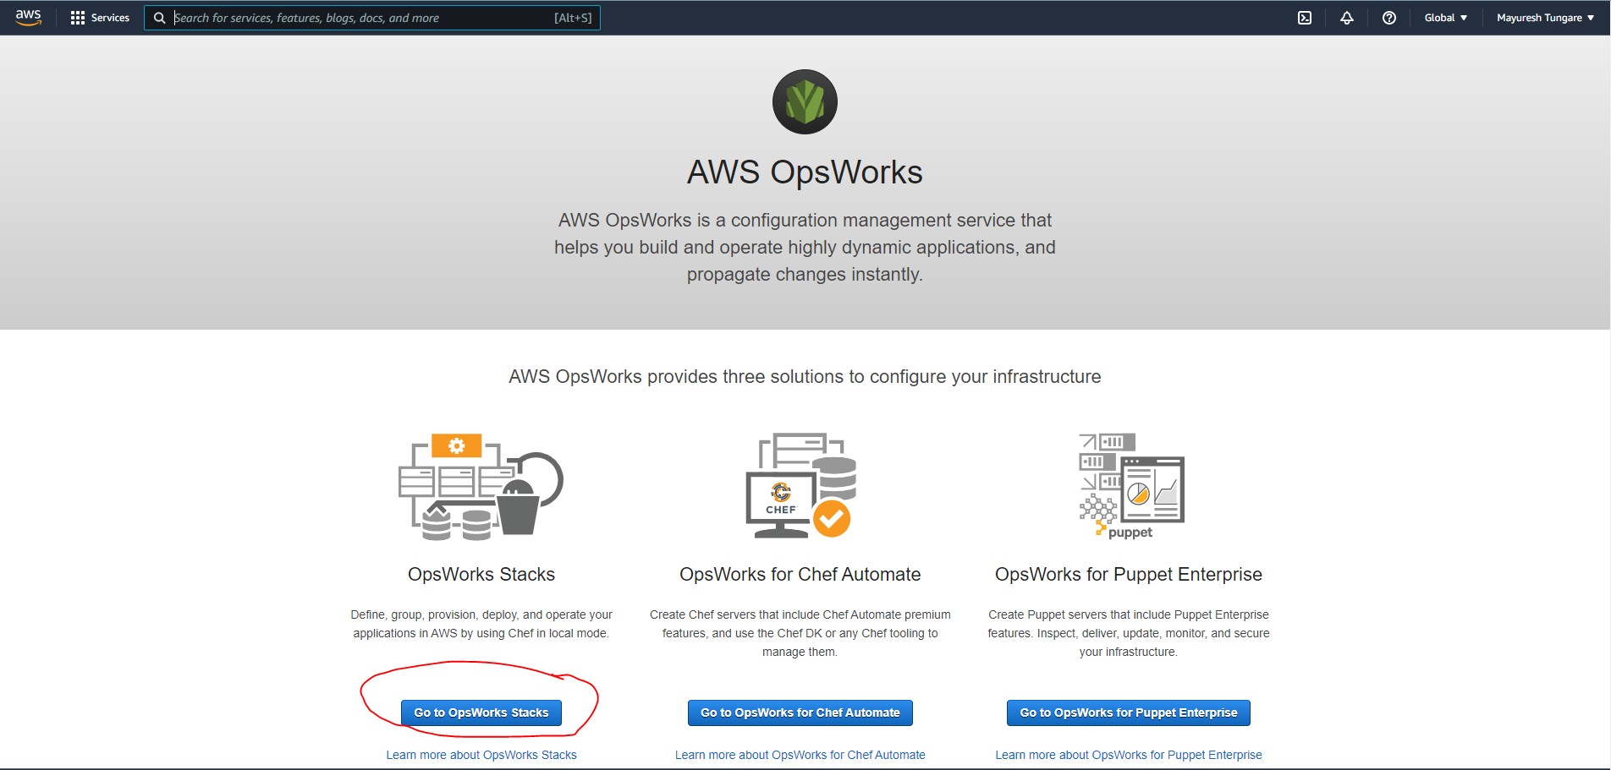

1. On the next screen, please choose ‘Add your first stack’ option:

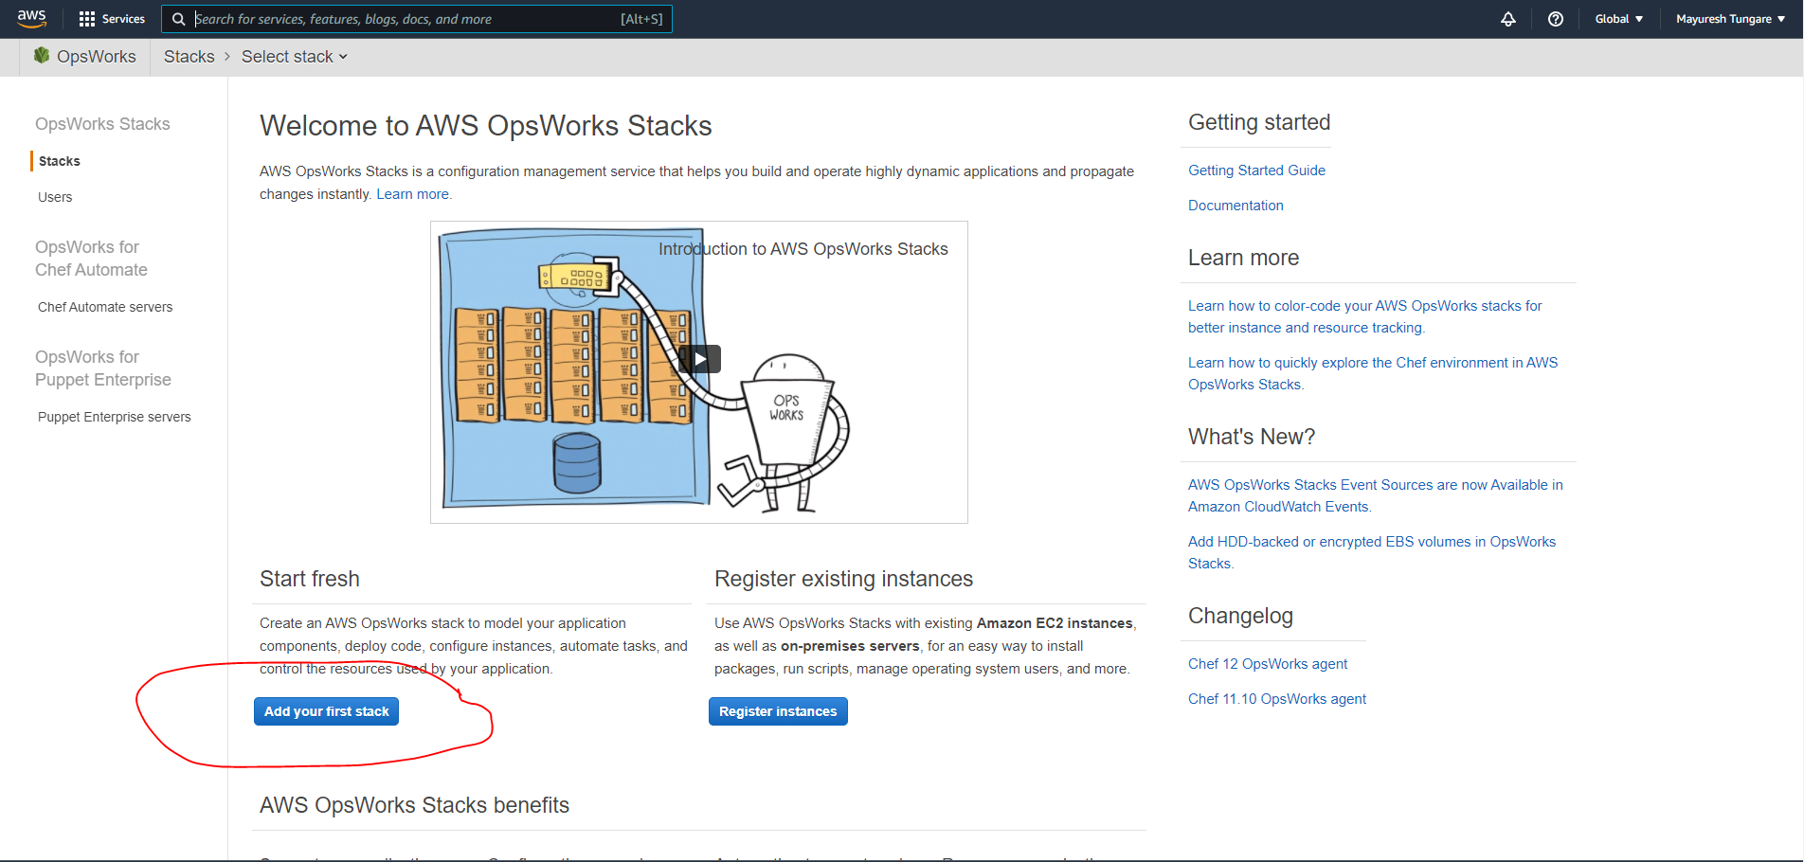

1. On next screen, we choose sample Linux stack and click on ‘Create stack’ as shown below:

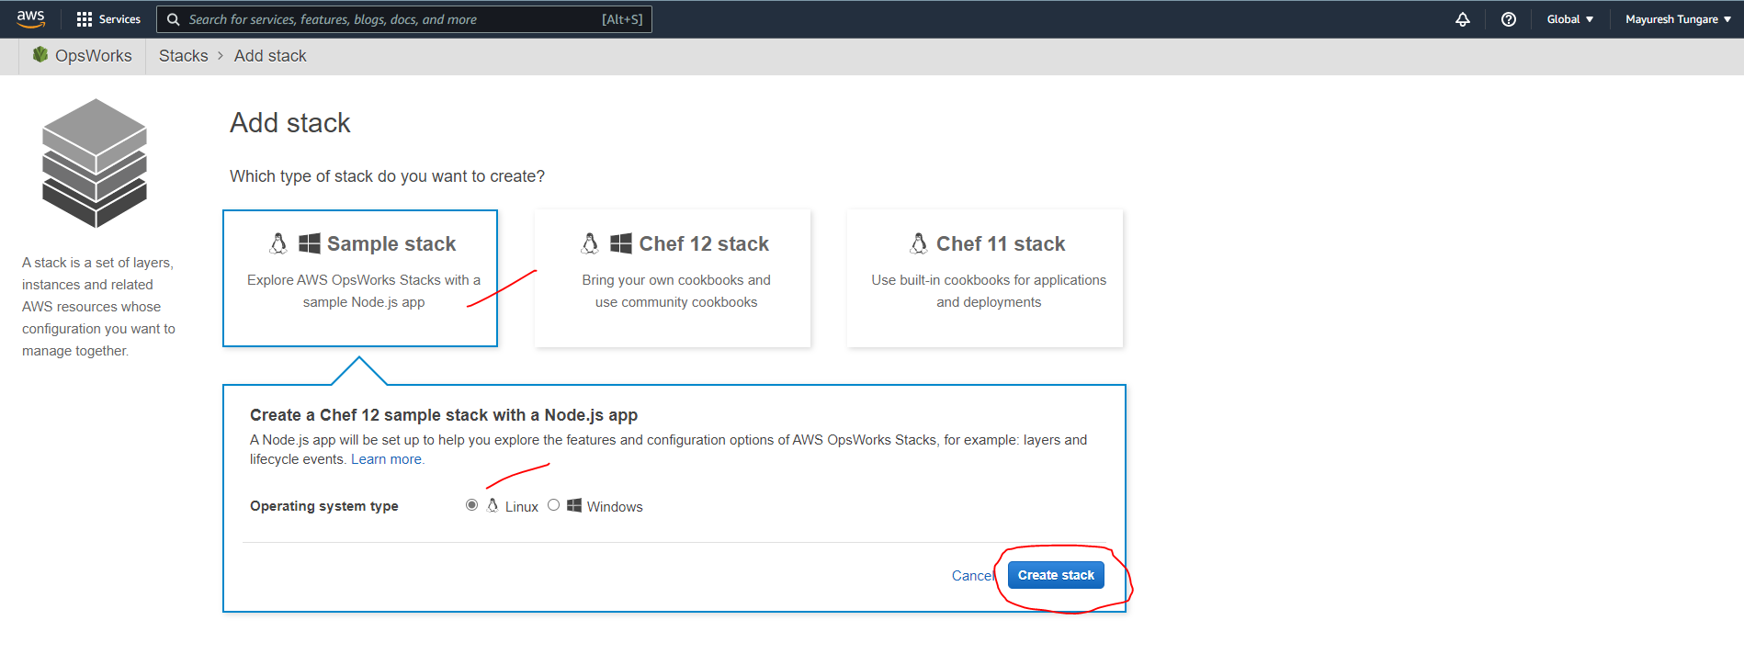

1. On next screen, you will see OpsWorks creating stack for you as below:

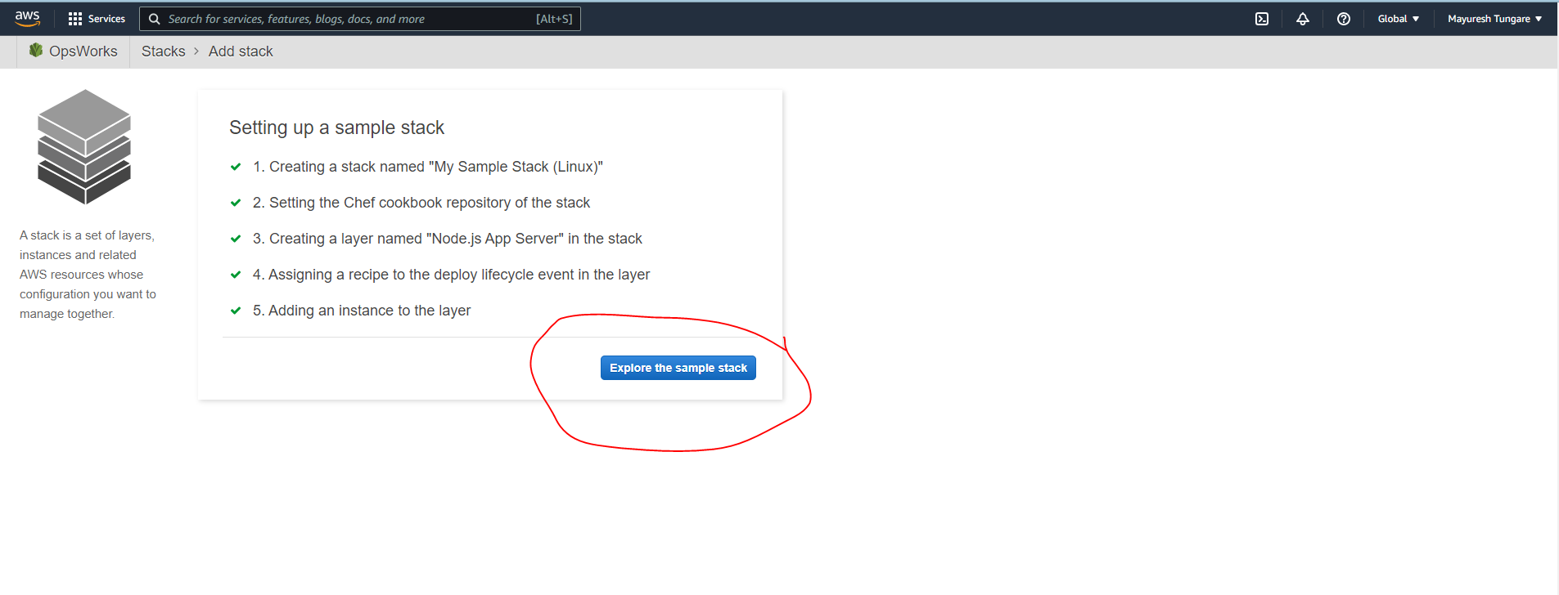

1. We notice that a stack has been created as below. 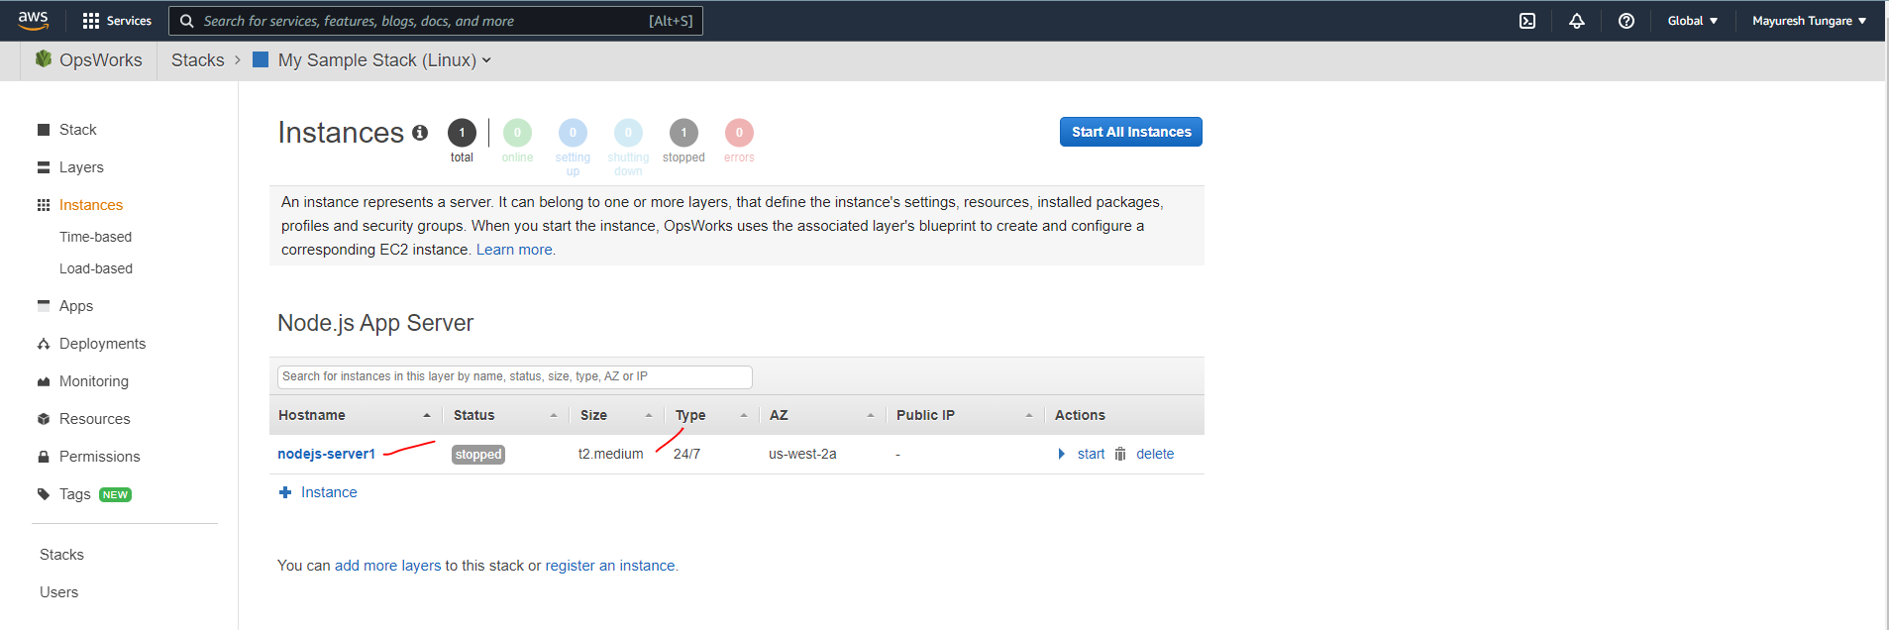
2. However, we change the instance type from t2.medium to t2.micro as shown below to remain within free tier and not incur any charges (shown below). We then click on Start All Instances.

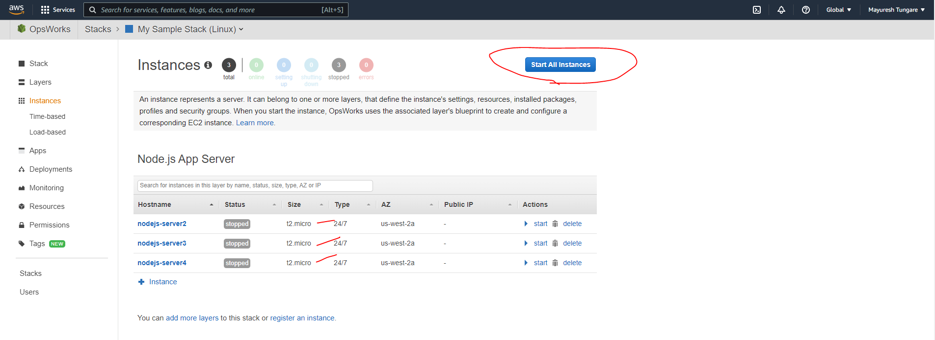

1. Next, we observe that all instances are now running (shown below) with their public IP addresses as **52.13.59.82**, **54.214.116.128**, and **52.12.218.190**.

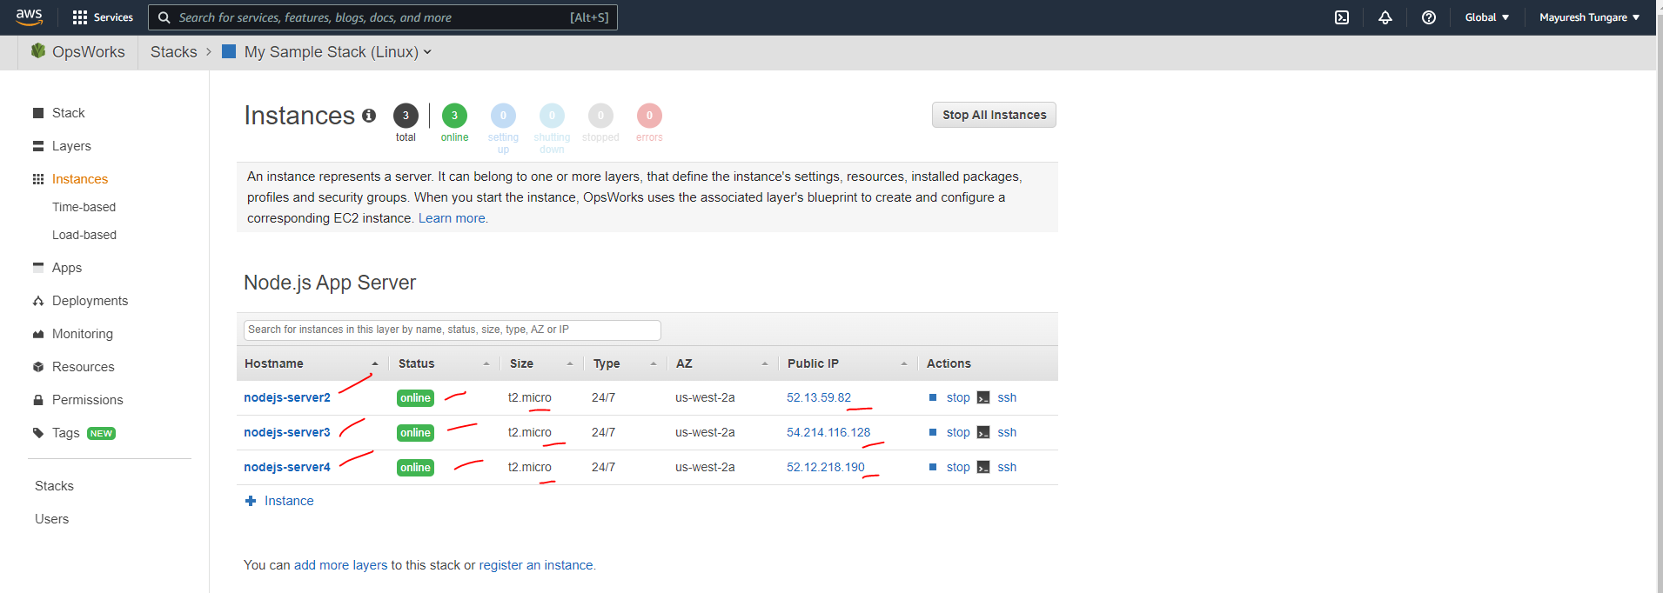

We can also confirm this from the EC2 dashboard:

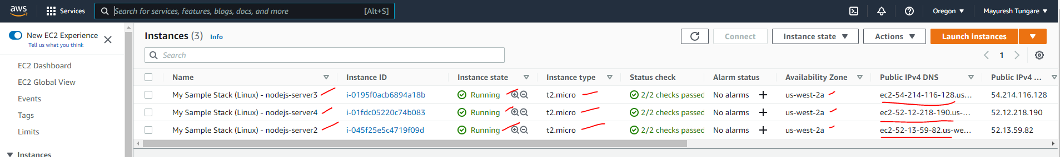

1. Thus, this assignment is now complete.